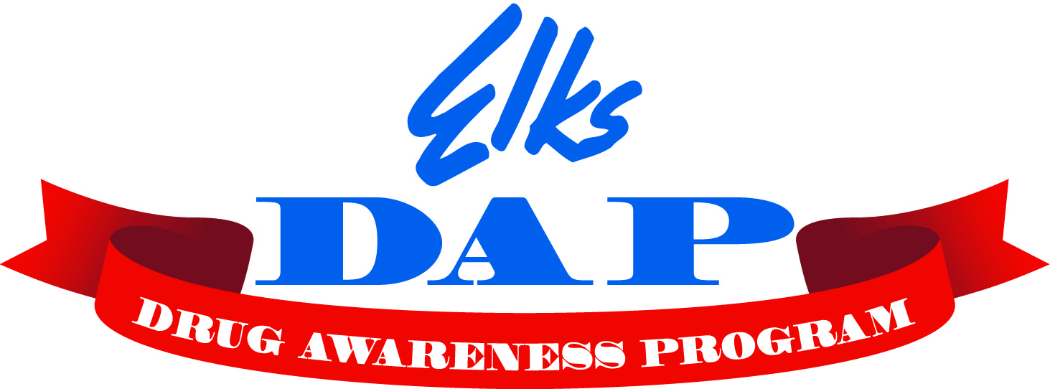
Elks Drug Awareness Poster Contest

The theme for the 2025-2026 contest is “DRUGS ARE A GRAVE MISTAKE”
Rules
The contest is open to all 3rd, 4th, and 5th grade students.

Poster paper: Ideally, posters should be submitted on 8.5 x 11-inch paper. However, posters submitted on paper up to 12x24 inches in size will be accepted. Participants must draw the posters themselves but may get ideas and review from parents, teachers, or friends. The Theme must appear on the poster.

Judging will be based on the following:
- Closeness to the theme
- Neatness
- Originality
- Correct grammatical structure
NO TRADEMARK CHARACTERS ARE ALLOWED
- No use of AI Tools

Each entry must have the following information:
- Student's full name and phone number
- School, location, grade
- Elks Lodge name
- Must also be accompanied by Hold Harmless Agreement

Due date:1
Return all posters for judging by January 17, 2026, to the Lodge chairperson, Deb Raible. The Lodge chair will select the top posters for each grade, and they will be forwarded to the district chairperson Derek Kerfoot by February 5, 2026. The district winners will be forwarded to state level competition by March 5, 2026. All winning entries become the sole property of the Benevolent and Protective Order of Elks and may not be returned.

National recognition: Each State Drug Awareness Chairperson will choose an overall winner. The winning poster will be submitted for entry into the National Elks contest and for inclusion in the Elks DAP coloring book. It may be featured on the www.elkskidzone.org website and/or in ENF or DAP publications.

