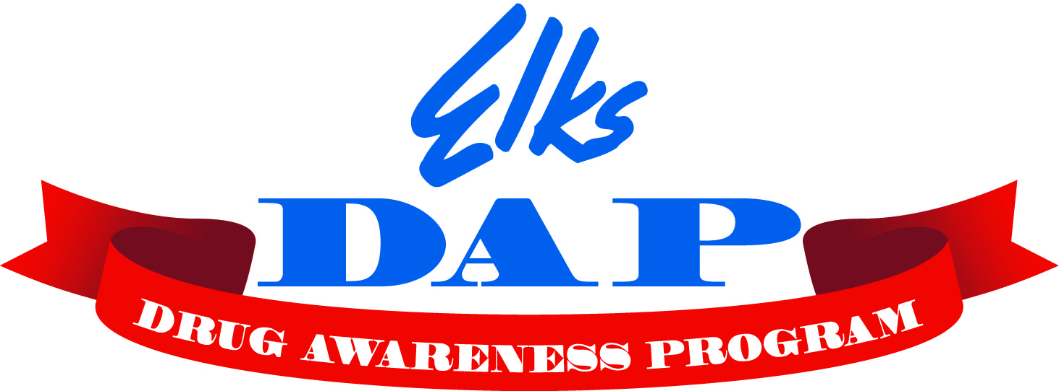
Elks Drug Awareness Essay Contest

The theme for the 2025-2026 contest is “DRUGS ARE A GRAVE MISTAKE”

Rules
The contest is open to all 6th, 7th, and 8th grade students. Participants must write the essay themselves, but they may get help from teachers, parents, or friends in the form of ideas and review.
- Length: no longer than 250 words
- Paper size: 8.5 x 11 inches
- Text: Typed, computer generated text, handwritten or hand printed
- Use of AI Tools are prohibited

Judging:
- Closeness to the theme
- Neatness
- Originality
- Correct grammatical structure

Each entry must have the following information:
- Student's full name and phone number
- School, location, grade
- Elks Lodge name
- Must also be accompanied by Hold Harmless Agreement

Due date:
Return all essays for judging by January 17, 2026, to the Lodge chairperson Deb Raible. The lodge chair will select the top essays from each grade, and they will be forwarded to the district chairperson, Derek Kerfoot by February 5, 2026. The district winners will be forwarded to state level competition. All winning entries become the sole property of the Benevolent and Protective Order of Elks and may not be returned.

National recognition: Each State Chairperson will choose an One overall winner. This winning essay will be submitted into the National Elks contest and may be featured on the www.elkskidzone,org website and/or in ENF or DAP publications.

