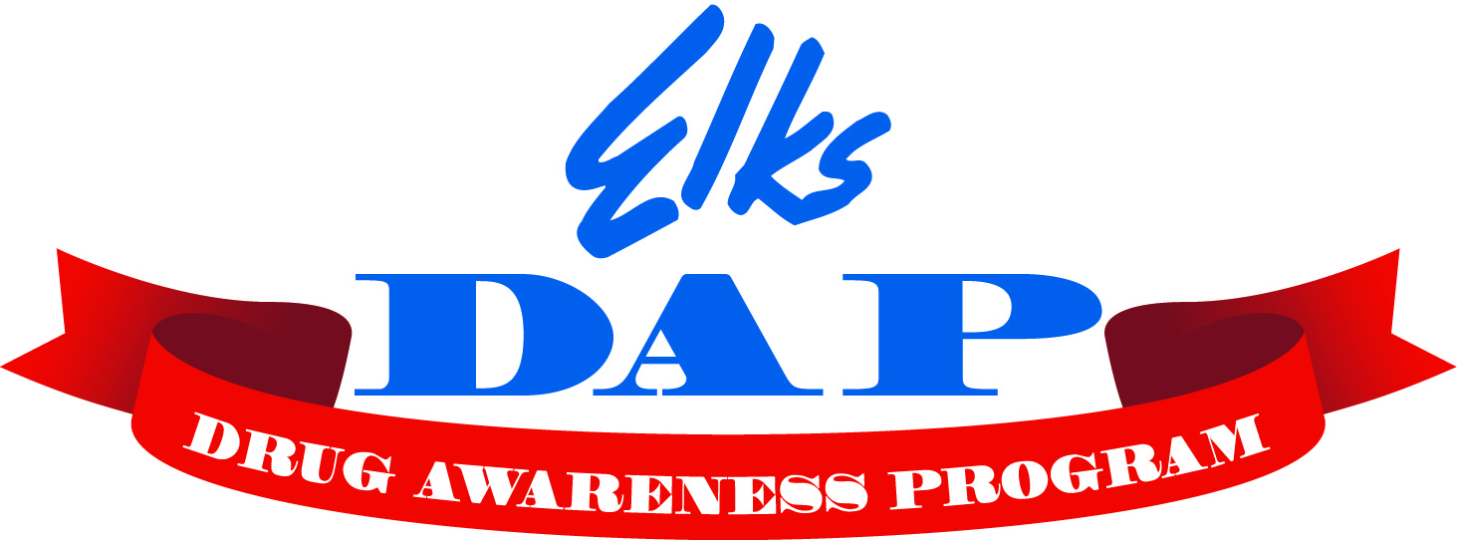
Elks Drug Awareness Video Contest

The theme for the 2022-2023 contest is “Drugs are a Grave Mistake”
Rules
The contest is open to two age groups: Pre-High School and High School

- Length: 2 to 5 minutes
- Owners: Maybe an individual or group of up to 3
- Format: Flash drive or similar mobile media in readable format
- AI Tools are Prohibited

Judging will be based on the following:
- Closeness to the theme
- Neatness
- Originality
- Age and Language appropriate
- Positive message
- Quality of the video
- Music

Each entry must have the following information:
- Student or group's name or names
- School, location, grade
- Elks Lodge name
- Must also be accompanied by Hold Harmless agreement

Due date:
Return all videos for judging by January 7, 2026to the Lodge chairperson (Deb Raible). The Lodge chair will select the top videos and they will be forwarded to the district chairperson Derek Kerfoot by February 5, 2026. The district winners will be forwarded to state level competition by March 5, 2026. All winning entries become the sole property of the Benevolent and Protective Order of Elks, and may not be returned.

National recognition: Each state Drug Awareness Chairperson will choose an overall winner. This winning video will be submitted into the National Elks contest and may be featured on the www.elkskidzone.org website and/or in ENF or DAP publications.

